

**DE-38 (MTS)**

**PROJECT REPORT**

**Autonomous Paramotor**

Submitted to the Department of Mechatronics Engineering

in partial fulfillment of the requirements

for the degree of

**Bachelor of Engineering**

**in**

**Mechatronics**

**2020**

**Sponsoring DS: Submitted By:**

|  |  |  |
| --- | --- | --- |
| Dr. Waqar Shahid Qureshi  Dr. Mohsin Tiwana |  | Rafay Mujtaba Umer Bin Mansoor  Raja Zohaib Ali |

# **ACKNOWLEDGEMENTS**

We would like to begin by thanking our project advisor [title] [Name Surname] for the [uni Fac] name at [Uni Nme]. He always opens the gate to his office whenever we face difficulties in our work and writing. He always leads us in the correct way every time he thinks we need him.

We would also like to give gratitude the persons who participated in the research to validate this work challenge: [Include a list of Titel professional, name participating / contributing professionals]. Without their help, we would never have fully mastered these machines.

Lastly, we need to express our deepest thanks to our parents for giving us with ongoing support and ongoing cheer throughout the years of testing and research. This achievement now would not have been possible without them. Thank you.

**ABSTRACT**

The project is basically about the world evolving and turning towards the autonomous technology. Hence our project is about making machines autonomous which already exists in manual mode. But still we need to build it from scratch, because definitely it would require new working principles and environment. So here, our project is basically developing a paramotor’s design, its physics, mechanical model and finally its mechanical structure. Later on its going to fly like a regular paramotor, with a motor behind, that will provide thrust which will create air pressure under the Para that is attached with the motor-engine. To make it autonomous we are going to install a flight controller PIXHAWK 2.1 which is flexible autopilot hardware. Along with it we are going to install a GPS module to track the machine’s flight. As this machine is not going to carry a human being but going to be used to throw seeds in the forest; therefore, the load is not going to be that much heavier. Also the flight altitude can vary according to the forest density; although altitude can be controlled by the motor’s thrust. It is going to fly on the coordinates provided through the GPS before the flight begin, and its motor will be powered by the battery. So yes this work is not possible without any research on the office grounds. Therefore we have initially worked on its simulations on the software (V-REP) before going on air. This task includes the simulation in Virtual Robot Experimentation Platform (V-REP) of the conduct of a powered Motor and parachute gladiator. The goal is to confirm that the robots can fly within the environment, in a standalone mode, in a strong and steady way. To obtain the proposed objectives, it was necessary to create a program in Lua and take a look at it in simulation. This concerned the take a look at of robot Dynamics and mechanics and notion from sensors. And we had been very fortunate to gain positive results from the simulation. Hence, this device goes to keep a lot amount of time, money, and manpower. UAVs have been used effectively in recent years for recycling and commercial purposes, and Signin Layout advances in the field of robust management software programs and hardware. However, testing prototype UAV structures means damage hazards because of failures. Inspired by this, the gadget is presented for a complete simulation of the powerful Gladiator UAV. The submitted system is located in the V-Representative Simulator. This integrated approach allows simultaneous simulation of different elements of ink at dynamics, imaging sensors and IMUs outside of complex environments such as onboard sensors.

**TABLE OF CONTENTS**

**ABSTRACT** ii

**TABLE OF CONTENTS** iii

**LIST OF FIGURES** vi

**LIST OF TABLES** viii

**LIST OF SYMBOLS** ix

**Chapter 1 – INTRODUCTION** 10

**Chapter 2 – Literature Review** 11

**Chapter 3 – Literature Review** 11

**Chapter 4 – Literature Review** 11

**Chapter 5 – Literature Review** 11

**LIST OF FIGURES**

Figure 1.

Figure 2.

Figure 3.

Figure 4.

Figure 5.

Figure 6

Figure 7.

Figure 8.

Figure 9.

Figure 10.

Figure 11.

Figure 12.

Figure 13.

Figure 14.

Figure 15.

Figure 16.

Figure 17.

Figure 18.

Figure 19.

Figure 20.

**LIST OF TABLES**

Table 1.

Table 2.

Table 3.

Table 4.

Table 5.

Table 6.

Table 7.

Table 8.

Table 9.

Table 10.

Table 11.

Table 12.

Table 13.

Table 14.

Table 15.

**LIST OF SYMBOLS**

**Latin**

M => Moment

P => Power

r => Radius

*F*  => Force

a => acceleration

v => velocity

l => length

*D, d* => Diameter

K => stiffness constant

f => coefficient of friction

*A* => Area

*m* => Mass

*V* => Volume

**Greek**

π => pi

ω => Angular Velocity

θ => Theta (Angle)

𝜏 => Torque

**Chapter-1**

**INTRODUCTION**

In the 1960s, propaganda about paragliding began in Europe. The performance of gliders has increased significantly. And easy to control craft due to sophisticated designs. It was a big step to make the flight. However, the development of the modern paragliders we know today requires a lot of time. There are some competitions in different categories also, lead to aerobic acrobatics such as spiral dive or full Stalls are frequent (Vittal, 2010). Many pilots Drive over large mountains such as the Alps to enjoy paragliding. The potential energy or start is transformed at altitude Kinetic energy to reduce the distance as much as possible. This process is called "gliding flight".

Our project is based on an autonomous machine. Our goal is to provide more efficient more economical and easier path to do work. We aim to automate innovate an existing machine which is a Paramotor or a powered paraglider.

Paramotor is a broadly common psrt for the saddle and propulsion component of a Paramotor paraglider (PPG). Two main types of paramotors: foot release and wheel release.

The foot release model includes a saddle, gasoline tank, engine and propeller. The enclosure with the shielding mesh contains the most off-drive species. The unit wears out like a huge backpack, with a paraglider attached to the carabiners.

Wheel release units come with their own motor as complete units or as an add-straight leg release paramotor. They usually have 3 or 3 or 4 (quad) wheels.

Since our project is not to carry any pilots, this is not a one-step experiment.

The pilot controls the thrust through the hand-held throttle, while our control is controlled by the flight controller and steer, which automatically shifts a mechanism through servo motors using a feather brake toggle. Is controlled by. It is similar to paragliding because it works so there is no need to use height or thermal to climb. The development of paramotor wings is mainly due to electric propulsion, which is compared to loose-flying 'paraglider' wings.

We also built a UAV robot in SOLIDWORKS and simulated it using a V-REP tool. In simulation, we create an environment in which we place our model and attach a sensor / camera that gives a direct view of the environment.

In recent years, unmanned aerial vehicles (UAVs) have become a tool for various researchers in the medical community so that you can develop tools that facilitate repetitive, complex or hazardous work responsibilities. The UAV is a vehicle that can be worn without the need for staff, although there is no need to keep the operator on the ground. It is possible to classify UAVs as highly profitable based on takeoff, dividing vertical takeoff, also known as VTOL (vertical takeoff and landing), which is a rapidly growing sector. UAVs include virtual vision dynamics, cameras and various sensors.

V-REP offers the opportunity to design our real-world work as a simulation base. Through its use, we can save our time and money. In V-REP, we build our model with the help of using element / primitive designs. Shapes are solid mesh objects made with triangular faces. They can be imported, exported and modified. They come in four distinct subtypes: common random shapes, mixed random shapes, common convex shapes, and mixed convex shapes. We use compound random shape. It refers to any mesh. It has many color and visual feature sets. Shapes are sociable, scalable, recognizable and renderable gadgets. Size as:

Coll can be used against other collision gadgets when a collision occurs. Meas can be used to calculate minimum distances with other measurable objects. Pro can be detected with the help of proximity sensor. Vision can be detected using vision sensors

We add joints to our model that allow it to rotate. Mixed means having at least one internal degree of freedom (DoF). Joints are used to build model and move objects. It connects to each other, allowing the complete model to rotate / move. In our project, we have 6 DoFs, all related to our model. We use inverted joints. Revolt joints contain DOF and are used to define rotational motion between objects (with 1 DoF). Their configuration is defined using a value that shows the rotation about the z-axis of their first recomended frame. They can be used as passive joints or as active joints (motors).After completing and assembling model in V-REP, we move to simulation part in which we define and parameters and physics of model which helps in simulate our model. This is UAV model so it can fly autonomously without the help of user or any external command. Two servor motor is attach with parachute which give the force/power to lift it up and reduce the gravity effect on it. When it comes down gravity increases and force decreases.

Despite all the improvements and awareness. Physical phenomenon and parameters, the complete model is not available, it is useful to simulate the dynamic behavior of the system. Purpose of this contribution to obtaining such mathematical models. It can be used to simulate the behavior of the system in the flying and gliding positions. It can be carried to one side. Evaluate the performance, safety and stability of paragliders and on the other hand optimize the towing process.

**Chapter-2**

**Literature Review**

**2.1 Mechanical Structure:**

The paraglider has one wing, which is connected by lines, risers and carabiners by the pilot.

**2.1.1 Paraglider Wing:**

The paraglider's wing has a parallel shape when viewed from top and has a marked left and left wing (indicators are often selected when referring to the plane's orientation). The wing made up of cells separated by walls.

The front part of the wing is called the front part and that is where the cell phones open. This is where the aircraft enters the wing and expands. The back of the wing is called the back line. Each assembly is called the outer ear, which leads to the wing pump. The distance between the tips of the wing is called the wing span.

The raised wing has an arc shape when viewed from the front and back. The wing is the difference between the wing of hope and the list of wings on earth. Similarly the difference between the measured area and the lower part of the wing. No matter how high the floor area is, the rated area will only carry the load.

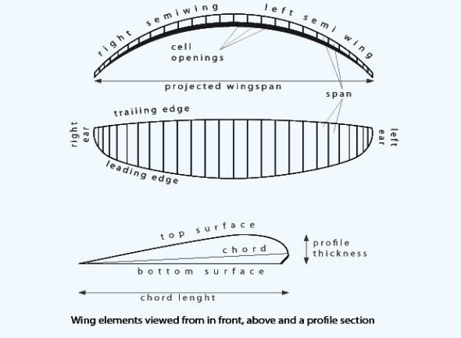

Figure 1

**2.1.2 Paraglider Suspension:**

* The pilot gives out the weight of the bundle on the wing floor;
* The wing gives a form;
* The spline sets the equilibrium angle on the extreme wing section (mandatory section, ear) by changing the span structure;
* Attack from the flight perspective of attack control.

The suspension includes strains, risers and carabiners. Lines relative to the cellular walls along the inner surface of the wings are connected to the Vista attachment point.

**2.1.3 Speed System:**

By pulling the cup system into the A riser‌, A, B, C and D are constantly pulled down and thus reduce the attack angle. This is called a speed system. Some paragliders have trimmers that have the effect of pulling or opening the closing riser and controlling the view of the attack.

|  |  |
| --- | --- |
|  |  |

Figure 2 Figure 3

**2.1.4 Paraglider harness:**

The paraglider saddle covers the body of the pilot and transfers its weight to the wing along the carabiners, risers and lines. Should be pressing:

• keep the driver's frame in all positions (even higher);

• allow the pilot to control the wing by moving his weight along the side of the road;

• Allow for the smooth ride and use of the speed system;

• have effective security devices (parachute rescue) and security devices (protectors);

• allow a comfortable position for the pilot to stay longer;

• allow sufficient freedom of movement (quick rush to take home, easy entry and exit).

**2.2 Autonomous flight:**

**2.2.1 PIXHAWK 2.1:**

Pixhawk 2.1 is the most widely available open-top opophot by the previous version of Pixhawk in all aspects. The pixhawk 2.1 aircraft controls the use of structural design, so you may want to choose unusual carrier boards that fit different needs. With a built-in heat exchanger powered by an IMU machine, the Pixhawk 2.1 is ready to operate at extremely low temperatures. The three-dimensional IMU system makes the aircraft more secure, increasing reliability, the IMU with dermening built-in translation drive makes better use of high vibration filters, reducing noise by IMU scales. And compared to the previous version, the anti-jamming and durability of the Pixhawk 2.1 improved significantly.

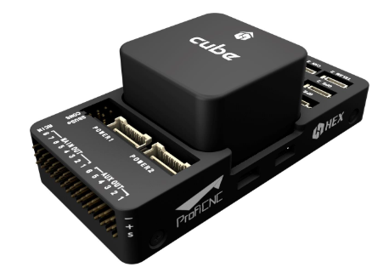

Figure 4

**2.2.2 Global Positioning System:**

Here's to using Nokia's Global Positioning System module and fly using the tracking method after using Global Positioning System. A Global Positioning System navigation device, a Global Positioning System receiver or Global Positioning System device that can retrieve facts from Global Positioning System satellites at all and then compute the location. It does not need the user to move any data, and it works itself of any telephone or internet reception, but this technology enhances the help of Global Positioning System position information. Global Positioning System provides critical positioning skills for military, civilian and commercial users worldwide. Using the right software, the tool can show the location on the map and provide instructions. The Global Positioning System (GPS) is a global satellite navigation system (GNSS) developed by less than 24 networks, although there are currently 30 orbiting satellites available.

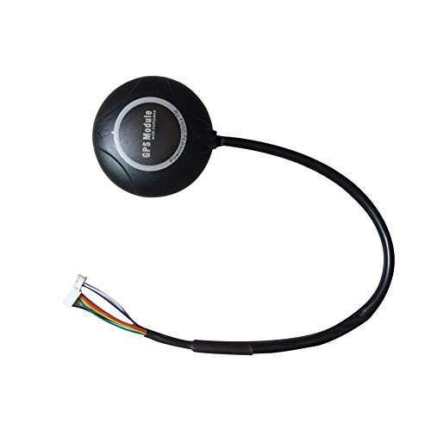

Figure 5

**2.2.2.1 Waypoint Following:**

Control layout method for Powered Paraglider (PPG) model. After creating a dynamic version with a six-diploma of PPG independence, a dynamic lateral version around the trim balance in the steady state plane is achieved. Static, drag modules, etc. It is a plugin of ROS as well. For setting waypoint following we need to publish either ROS directly or use RVIZ which is tool of ROS. Unknown parameters in lateral models are adapted by real flight experimental data. Model output with agreed flight parameters with actual flight experimental data. Since the parameters related to aerodynamics, i.e. drag coefficients, are slightly closer to maintaining the modified triangular equilibrium, this paper considers its uncertainty in the constructed lateral model. To stabilize the lateral pattern (with aerodynamic uncertainty) on the considered operational domain, the non-linear controller is built with the help of resolving strong controller layout conditions expressed in terms of linear asymmetry. The experimental impact control gadget layout combined with the automatic touchdown reflects the effect of the framework, which is a strong static control that takes into account correction uncertainty and correction uncertainty.

**2.2.3 Servo motors:**

Servo motors are used to control the flight mechanism, to engage the motor's excitation, and to control the wing suspension.

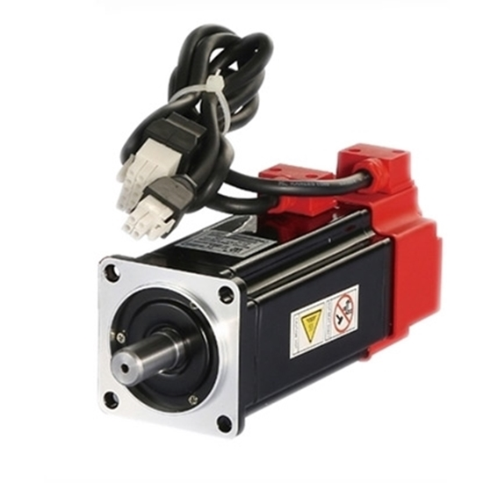

Figure 6

**2.2.4 Power Plant:**

The power generator is a small two-stroke internal combustion engine between 80 cc and 350 cc that burns a combination of gasoline and oil. These locomotives will soon have a higher RPM. Considering approximately 3.7 liters of gas usage, thrust and reduced weight, paraglider capacity, unit plus pilot load and hours depending on aircraft weather conditions. At least one manufacturer is building a 4-stroke model with its strongest low RPM. Thrust and high fuel efficiency.

Electric-powered devices are an addition, although flight duration on the battery's electrical capacity is appreciated. So in our case we use a battery powered plant.

|  |  |
| --- | --- |
|  |  |

Figure 7

**2.3 Software:**

Softwares to be used in our project shall be:

* Solid Works for CAD modeling
* Software in Loop Simulator

**2.3.1 Gazebo:**

Gazebo is a well-known and respected robotics simulator. It makes possible to test algorithms, design robot and simulation. Gazebo can use multiple excessive performance engine, inclusive of ODE, BULLET etc. It provides sensible rendering of environments including incredible lighting, shadows, and textures. It is a ROS plugin we cannot use GAZEBO independently. For using gazebo we need to install UBUNTU and ROS. It is likewise the legit DARPA Virtual Robotics Simulator. No current release has built-in help for ArduPilot.

In our architecture we are designing an algorithm which detects objects and fly the gladiator in the environment. The platform which we are using in our project is V-REP an UBUNTU because this operating system is providing multitasking and topics to exchange data. We are using V-REP simulator which provides us our desired environment and sensors which are required for the project.

**2.3.2 V-Rep:**

It is (V-REP) - 3D robot simulation software with a comprehensive development environment with many computational modules such as inverse dynamics, physics / dynamics, collision detection and route planning. It also allows you to model, modify, program and simulate any robot or robot system (sensors, mechanisms, etc.).It also provide multiple function and can make integration with LUA APIs and script function. It don’t require ROS and UBUNTU for simulation. We can use this in Windows (OS) also and do our simulation. It is better than other simulation software. As like as Gazebo, V-REP can also use multiple high performance engine, such as ODE, BULLET, NEWTON etc.

V-REP is a strong robot 3D integrated development environment, which has several universal

calculation modules (inverse kinematics, physics/dynamics, collision detection, minimum distance

calculation, path planning), distributed control architecture (control scripts of unlimited number,

thread or non-thread), and several extension mechanisms (plug-in, client application programme and

so on.) [7]. It provides multiple functions and can make integration and combination easily by detailed

API and script function.

V-REP is a strong robot 3D integrated development environment, which has several universal

calculation modules (inverse kinematics, physics/dynamics, collision detection, minimum distance

calculation, path planning), distributed control architecture (control scripts of unlimited number,

thread or non-thread), and several extension mechanisms (plug-in, client application programme and

so on.) [7]. It provides multiple functions and can make integration and combination easily by detailed

API and script function.

Major part of our project is being done on this software. We tried numerous softwares and find this one the best suitable one for our purpose. The platform which we are using in our project is UBUNTU or WINDOWS because this operating system is providing multitasking and topics to exchange data. We are using V-REP simulator which provides us our desired environment and sensors which are required for the project. Hence our complete simulation is based on V-rep simulator.

|  |  |
| --- | --- |
| **V-REP Simulator** | |
| **PROs** | **CONs** |
| V-REP is well suited for the precise configuration of robotic packages such as traffic or circuit surveys, in addition to various industrial systems, where certain robots are required simultaneously. | V-REP is the very difficult and the very open source. |
| The translation library is still distributed via V-REP and that is why you should always have it offline. |  |
| Storage is stored / stored in a unique V-REP format. All configuration settings should therefore be made using the V-REP display. |  |
| There are a variety of programming methods, as well as code attached to models, plug-ins, ROS files or separate packages connected to V-REP thru Remote. |  |

Table 2

* Hardware in Loop Simulator

**2.3.3rX-Plane:**

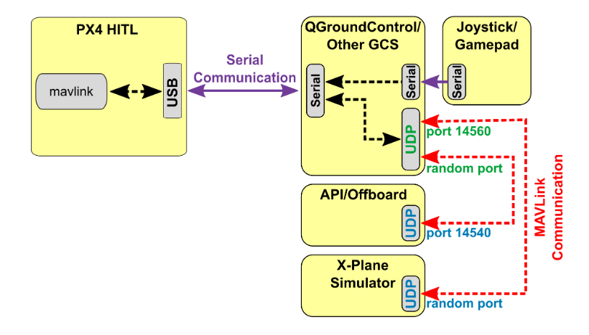

QGroundControl is paired with flight controller hardware via USB controller hardware and acts as a gateway for more information on the X-Plane simulator, enhanced computer gait, PX4 and any offboard API. The diagram below indicates the simulation environment:

* HITL Configuration (via QGroundControl) selected that does not enable the actual sensor
* G QGroundControl Reaches Flight Controller via USB
* D reached QGroundControl Simulator and Offboard API via UDP
* Serial connection is used to attach the joystick / gamepad hardware through G QGroundControl

**Mapping Software:**

**ESRI:** Develop the world's most effective mapping and spatial analysis software archeology. ArcGIS software programs and applications combine mapping and fact analytics to provide ambient intelligence and meet the digital transformation needs of organizations of all sizes. It is used to create and use maps, to compile geographic data, to analyze mapped information, to share and search geographical information, and to use map and geographic information in multiple applications and to manage geographic information in a database.

The system provides the infrastructure to make maps and geographical information public in an organization and on the Web.ArcGIS includes the following Windows desktop software:

* Archrider, which allows you to view and query maps created with other ArcGIS products;
* Arkizis Desktop (also known as "Arcpack" to distinguish it from Arkjis Pro), is designed with four basic applications:
* Arc map, to view and edit spatial data from two angles and to create two dimensional maps;
* Arcassen, for viewing and modifying three-dimensional spatial data in a local approximation view;
* Arc Globe, to display large, global 3D datasets;
* For arc catalog, GIS data management and manipulation functions.
* Archizis Pro is a new, integrated GIS application that ultimately plans to roll out Archpace and its partner programs. Ark‌gis Pro works for cartography and visualization in 2D and 3D and has artificial intelligence

**Chapter-3**

**Hardware**

**3.1 Parachute Mechanism**

An apparatus for supporting a parachute flight controller from a parachute we're going to use a bearing member, as an instance a pulley, a load-bearing coupling, as an instance a harness, related to the bearing member and which include a connector for connecting the coupling to a parachute flight controller. The coupling consists of a load-bearing connector for connecting a payload thereto, and the bearing member is tailored to enable relative motion, controlled by means of the flight controller, among the bearing member and a aid member, for example a flexible coupling line or web for helping the bearing member related between first and 2nd suspension lines of a parachute. The flight controller may encompass one or more manage traces related to the guide member or suspension lines which may be wound in or out of the flight controller to impact relative movement between the bearing member and the assist member and thereby control the direction of the parachute.

Paraglider trajectory dynamics, as Also, its turning angle is driven by complex interaction Between gravity and drag force. Differential equations describing this dynamic behavior are developed by balancing all the forces and torques acting on the system. The developed model allows to compare different flight conditions and find the correct values ​​of the parameters, which For example optimization will be used in the next steps. The process of flying Paraglider simulation results. The launch process is compared with actual data using an unleashing winch with the vehicle and then gliding in different wind conditions.

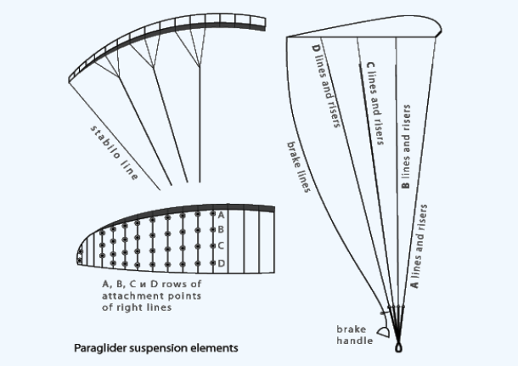

Figure 8

**3.2 Flight Controller**

We are going to use Pixhawk. 2.1 Open Source Autopilot, which is far ahead of the previous model Pixhawk in all respects. Pixhawk 2.1 adopts modular design for shuffling in flight so that you can select specific provider boards with specific requirements. Pixar 2.1 is related to operating at very low temperatures, with built-in heat-generating inhibitors for temperature-controlled IMU gadgets. The triple redundancy IMU machine additionally makes flight safe, greatly enhances reliability, with IMU's built-in vibration system, which filters high frequency vibrations and reduces noise to IMU measurements. Compared to previous models, the anti-jamming and balancing of the Pimp 2.1 has been greatly improved.



Figure 9

**3.3 Global Positioning System**

Here's to using Nokia's Global Positioning System module and fly using the tracking method after using Global Positioning System. A Global Positioning System navigation device, a Global Positioning System receiver or Global Positioning System device that can retrieve facts from Global Positioning System satellites at all and then compute the location. It does not need the user to move any data, and it works itself of any telephone or internet reception, but this technology enhances the help of Global Positioning System position information. Global Positioning System provides critical positioning skills for military, civilian and commercial users worldwide. Using the right software, the tool can show the location on the map and provide instructions. The Global Positioning System (GPS) is a global satellite navigation system (GNSS) developed by less than 24 networks, although there are currently 30 orbiting satellites available.

**3.4 Servo motors**

Servo motors shall be used to control the flight mechanism, engaging motor’s thrust, controlling the wing suspension etc. Servo motor are used on radio-controlled aircraft to set up control areas such as elevators, crutches, robot navigation, or active gripper. They are small in size and have built-in controls and have good power for their size.

In the food and medical industries, the tools are designed to be used in harsh environments, where the full filling capacity is high due to washing at high pressures and repeated temperatures to maintain strict hygiene standards. Serosos are also used in line making, where high repetition is required yet precise work.

There are two types of servor motor.

* AC
* DC

When these servos are ordered to be emptied, they move to that location and retain that location. If the external force is moving towards the servo when the servo has a position, the servo will prevent it from coming out of that position. The maximum servo energy collected is called the servo balance. Servos do not hold their position permanently. The driving position must be repeated to teach the servo to stay in position.

**3.5 Power Plant/Motor**

The power generator is usually a small 2 stroke internal combustion engine between eighty cc and Three Hundred fifty cc, which burns all the fuel and oil. These locomotives will soon have a higher RPM. Weight and reduced weight, gasoline use paraglider capacity of approximately 3.7 liters is phased in, depending on the unit plus pilot's load and aircraft conditions of a weather. At least 1 making has its strongest flaw r.P.M. Building a preferred 4-stroke model for. Thrust and high gasoline capacity.

Although flight time is very limited in the battery's electrical capacity, there are also gadgets that run on electricity.

**3.6 Battery**

The battery being used is rechargeable Lithium Ion Battery Pack 24V 10400mAh High Capacity Li-ion Battery Pack for Electronics, Lighting, Equipment.

24v 10400mAh high capacity lithium battery pack, Maintain 60% capacity for 1000 times of cyclic charging, and increase the cycle life by 50% compared with NIMH.

Length: 4.95inch, Width: 2.95 inch, Height: 2.64 inch.

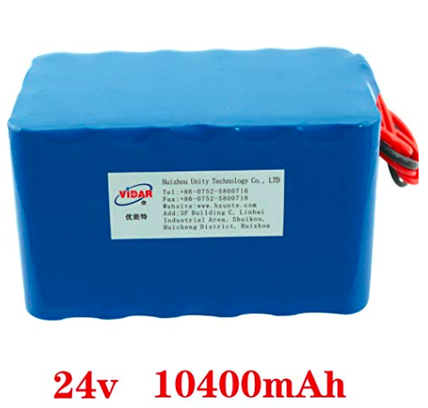

Figure 10

**Chapter-4**

**Software Report**

For the software side of our project we are currently working on the number of software.

**4.1 Ubuntu based OS**

It is an open source Debian based primarily Linux distribution. Canonical Limited. It sponsored using is review a great distribution for beginners. The operating system is intended not only for personal computers (PCs), but also for use on servers. Ubuntu includes thousands of pieces of software starting with Linux kernel versions 5.4 and GNOME 3.28, and includes everything from word processing and spreadsheet applications to Internet access applications, web server software, email software, programming languages, and tools. Cover desktop applications. Many sports. The platform which we are using in our project is UBINTU Operating System because this operating system is providing multitasking. We are using V-REP simulator which provides us our desired environment and sensors which are required for the project.

We are basically the usage of this OS for overall development of project.

|  |  |
| --- | --- |
| **UBUNTU** | |
| **PROs** | **CONs** |
| Simplified Installation | The Commercial Controlling the Community |
| There are a lot less viruses | Increasing Insularity of Development |
| An Emphasis on Localization | Forgotten Roots |
| Concern About Usability | Privacy and Security Issues |

Table 2

**4.2 Visual studio code**

It is a supply-code editor developed by Microsoft for Windows, Linux and MacOS. It have debugging, assembled jet manipulation and support for GitHub. It is uniquely customizable, allowing users to implement extensions that add themes, keyboard shortcuts, preferences, and additional functionality. The supply code is issued loosely and under an open supply and licensed MIT license. Compiled binaries are freeware and do not freeze for personal and industrial use.

This software is used to generate code to compile the firmware. In this software we can write code in C plus plus as well as in python and many other languages is written in this software. C plus plus and python, both these language is supported by our Simulation tool VREP. Visual studio is very easy to use and we can easily debegg our program in it. It is free from bugs and faults like other programming tools.

**4.3 Eclipse (software)**

Eclipse IDE used in PC coding. It has a base workspace and an extensible plug-in machine to optimize the environment. Eclipse is written throughout Java and its primary use is to expand Java packages, but it is also available in Ada, ABAP, C, C ++, C # and Couture‌. . Include. Cobol, D, Erlong, Fortron, Groovy, Haskell, JavaScript, Julia, [7] Lasso, Lua, Natural, Pearl, PHP, Prolog, Python, R, Ruby (including Ruby including Ruby), Rust, Scale and Plan. The software can also be used to develop packages for documents with latex (via the Texlips plug-in) and Mathema. Development environments include Eclipse Java Improvement Tools (JDT) for Java and Scala, Eclipse CDT for C / C ++ and Eclipse PDT for PHP.

This software program joins hands with visual studio code to assist in compiling firmware.

**4.4 C GUI**

This is a programming based Graphical User Interface using C/C++ and LUA python language to make firmware cmake files. The Graphical User Interface is show the front end to users. The code written in backend is not visible to users. We are using VREP tool for simulation and writing script in python LUA.

**4.5 Qt ground control**

Qt Ground Control provides complete flight control and mission planning for any MAVLink capable drone. Its primary goal is ease of use for professional users and developers. All code is open source, so you can collaborate and develop as you wish.

It is used to synchronize the flight controller with the mechanical model. Qt Ground Control Pixelwalk enables implementation of Autonomous Flight Control.

**4.6 Gazebo with ROS**

Gazebo 3-D simulator, because at the same time ROS works because of the interface of robots. Powerful robot simulator combining the two results. With Gazebo you can create 3-D scenes with robots, obstacles and many different objects on your laptop. The gazebo also uses a physical engine for lights, gravity, inertia and more.

Gazebo Simulation is a robot simulator built with a gazebo, which is a three-D simulator that must be capable and effectively mimic the robot population. It is similar to the Sport engine, but produces more simulation and provides a suite of sensors and interfaces for customers and programs. The gazebo is additionally integrated with the ROS framework and is an open supply solution, which allows for full management on the simulator.

V-REP is a easy to use and user-friendly simulator, and have packs extra tools.

Gazebo is further integrated/link into the ROS framework and is an open-supply solution that allows for full management of the simulator. But this requires some external gear to match V-REP functions. Also, Gazebo is more hardware-annoying than V-REP. Therefore, epistemologists should be more at risk of applying and validating their cognitive principles using V-REP than Gazebo, as V-REP is packed with additional clear and user-friendly simulator, and more features. Gazebo is included in the ROS framework and is an open source solution that allows for full management

Simulator. But it requires external gear with V-REP functionality. Also, Gazebo is more hardware-annoying than V-REP. Therefore, while epistemologists may have a greater risk of applying and validating their cognitive principles using V-REP than Gazebo, V-REP packs a more intuitive and user-pleasing simulator and additional features.

The gazebo is further integrated into the ROS framework and is an open-supply solution that allows complete control over the simulator. But V-REP operations require a lot of external equipment. In addition, the Gazebo is more hardware-demanding than the V-REP. Therefore, the cognitive scientist must take a good risk to apply and validate their cognitive principles, using V-REP over the gazebo, V-REP extra clear and user-pleasing simulator and more Features packs. Gazebo is additionally embedded in the ROS framework and is an open-supply solution that allows complete control over the simulator. But this requires many external devices to be compatible with V-REP functionality. Additionally, the Gazebo is more hardware-stressed than the V-REP. Therefore, epistemologists should be at better risk of applying their cognitive theories and verifying the use of V-REP than the gazebo.

It has the following main components:

• World files – have all the things in a simulation, all along with robots, like, lights, joints, sensors, and static objects.

• Models – represent character factors. The 3 robots and the object in front of them are models.

It’s going to be useful in generating a simulation (SITL) of Paramotor.

**4.7 PX4 Toolchain for Windows**

The PX4 Autopilot is an open source autopilot engine aimed at cheap independent aircraft. Utilize the passion in small remote aircraft operated by low cost and availability aircraft. The project began in 2009 and is still under development and is being used by ETH at the Computer Vision and Computer Geometry Lab (Swiss Federal Institute of Technology) in Zurich and supported by the Autonomous Systems Lab and the Automatic Control Laboratory. Many companies are currently producing PX4 autopilot and other services. Allows autopilot remote-controlled aircraft to go undetected. All hardware and software tools are an open and free resource that everyone must do under a BSD license. Free software autopilots provide additional hardware and software. Users can completely change the autopilot based on their specific needs.

An open source open system has everything that allows fly engines to fly in the air:

* G QGoundControl and MAVLink Micro Air Vehicle Communication Protocol.
* Air 2D / 3-D maps over the air (with Google Earth support)
* Way Way Point Drag and drop points.
* We use this software to upgrade PixWalk firmware in Windows.

**4.8 Drone scan**

Drone‌scan has developed an aerial virtual collection tool to provide large uniform warehouses with robotic answers for stock tech (inventory) and to provide feedback and integration with warehouse management structures. It has been proven to save man-hours of mass, but offers a safer alternative to standard labor intensive strategies involving many trucks, forklifts, man-cages and scissor-lifts.

Drone scans drones to test barcodes on each pallet and records the location of each object in the warehouse management gadget, proving that it is 50 times faster than manual capture.

Dronescon uses cutting-edge drone platforms, hardware, software, scanning and communication eras and currently integrates warehouse management systems and Excel.

The droneకాscan device offers revolutionary solutions for scanning objects and pallets in the warehouse. Moderate systems such as drone and dronescon payloads reach high cabinets and systematically move corridors that scan barcodes. Or Buffalo unit raised to the appropriate shelf height using a forklift, even if the operator receives a comment while scanning.

**4.9 V Rep**

V-REP - Virtual Robot Launch Platform - 3D robot simulation software with a comprehensive development environment that allows us to model, edit, program and simulate any robot or robot system (eg sensors, structure, etc.). V-REP is much more helpful and easy to use a simulator than Gazebo. V-REP and Gazebo are two commonly used simulation platforms. V-REP was chosen as the simulator for two main reasons, both for its advantages and disadvantages:

• It supports Linux, Windows and Mac OS while Gazebo only supports Linux-based Operating Systems (OS)

• It puts less load on the computer, which is an advantage when planning to simulate the project .

V-REP supports other strong and useful features such as,

• Available model browser

• Data recording and visualization

• Path and motion planning

• Embedded scripts

• Proximity sensor simulation

• Collision detection

It is also going to be used side by side with Gazebo to generate simulation; to do software in testing loop of the Paramotor. Out of all these softwares we find this one the most suitable for the job. So our work is based on the V-rep simulation.

Vrep has three CENTRAL ELEMENTS

* Scene Object Properties
* Calculation Modules
* Control Mechanisms

Below is explanation of our Simulation in V-REP:

**Scene Object Properties**

Scene Object has lights, camera, sensors, meshes, paths, joints, points cloud etc all these things combine to make a scene/environment. Each simulation randomly generates three sets of environment types: wall, forest and hills. All information of the generated map is stored e.g. obstacle heights, width and position. The simulations environments are generated with only two inputs, what type of environment and the desired number of obstacles. Even though the generation algorithm is randomly generated there exist a number of limitations,

• There must exist an obstacle free path to the goal

• The objects remains static, with physical properties

• The maximum obstacle density is 50% of the total map area

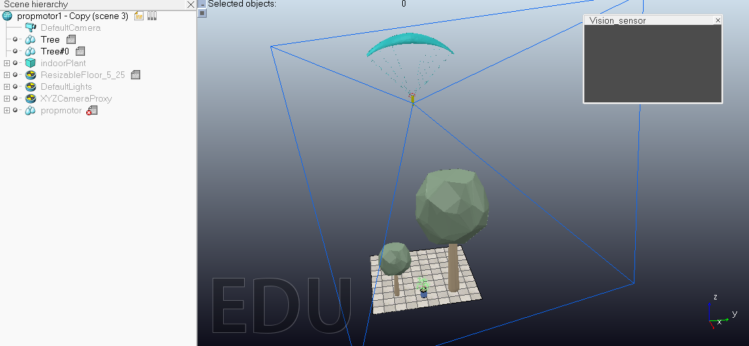

First of all we create Real world Environment using object properties.

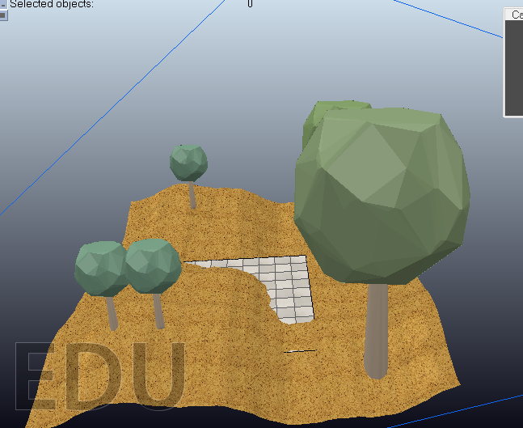

In this scene, we add terrain surface and add trees and make them detectable, measureable and collideable which is detected our vison sensor and collide our paraglider.

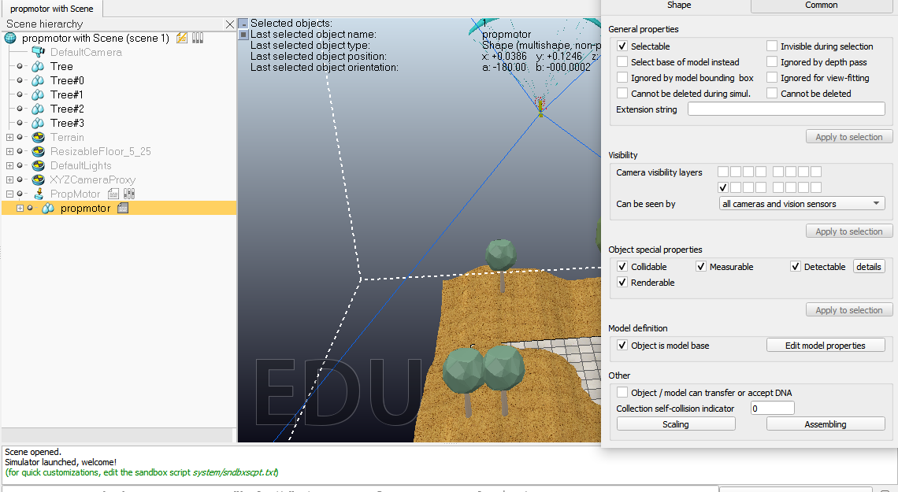

The camera_view shows the real time image of environment.

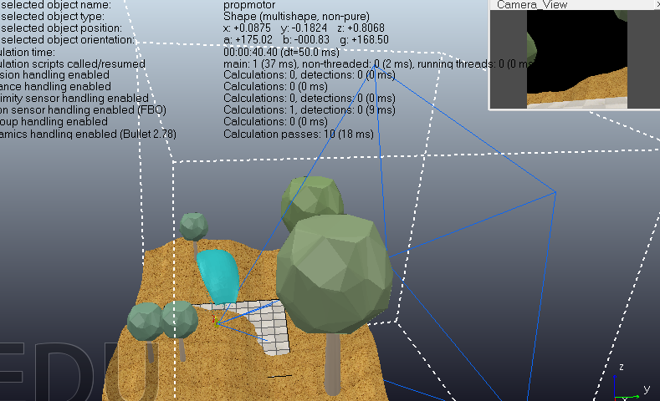

For Viewing objects in Environment, we select sensor view properties using calculate module properties. We select perspective view with 60 degree and near and far range with resolution X/Y 512.

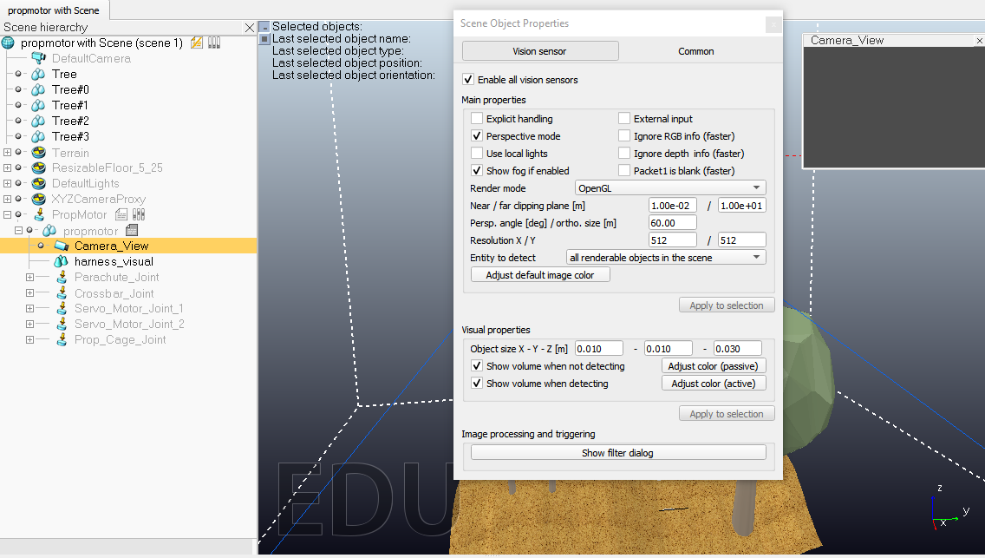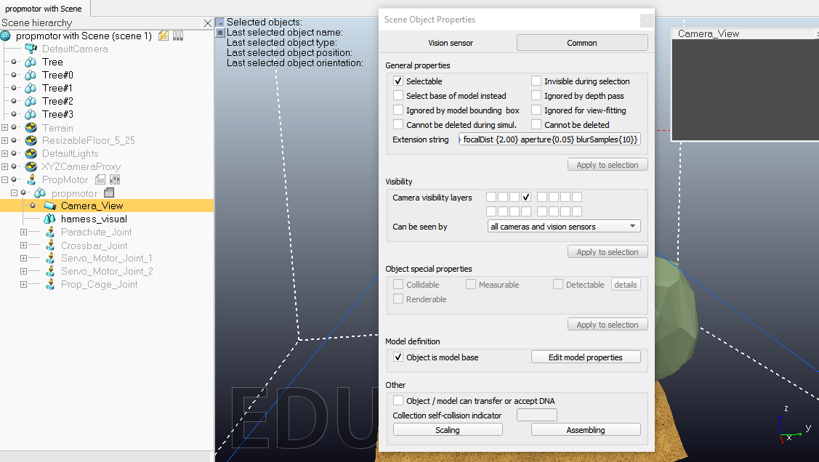

**Calculation Module**

In calculation module part, we calculate the physics and dynamic properties of our model which helps it in flying and come downward. For the simulation of our model, we make our model is dynamic and calculate its principal of moment of inertia, set mass, and matrix of inertia frames and COM relative to shape frames.

In the picture given below, we set the model object properties in which we mark model is detectable, measureable, collideable and renderable and mark tick for camera visible layer so that it can visible in our view/environment.

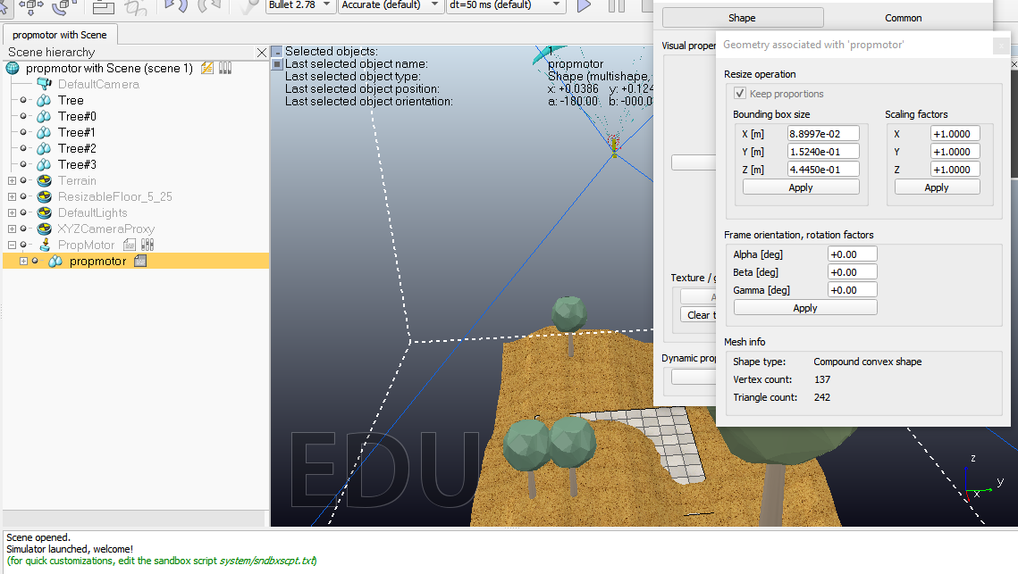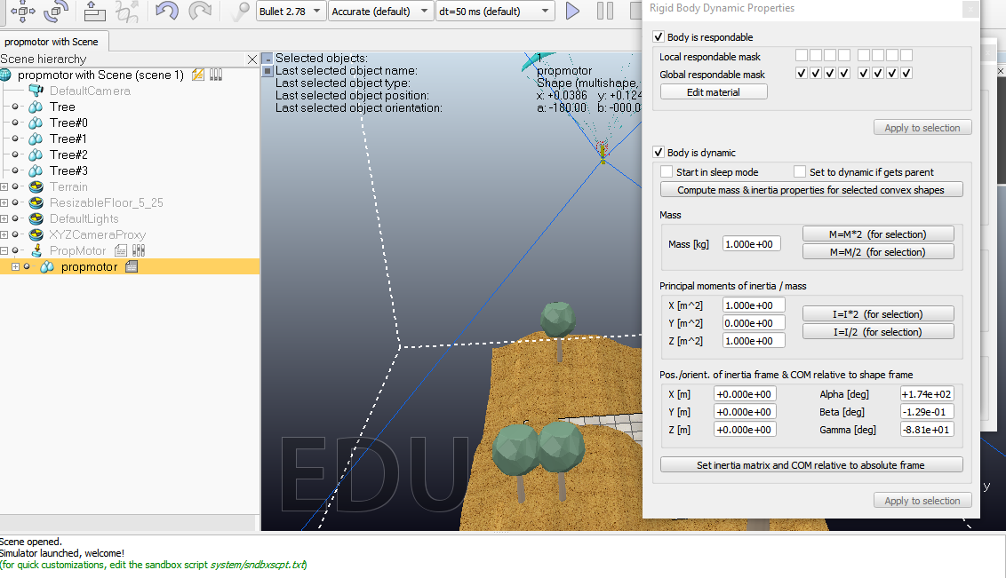

In the picture given below, we set the gravity effect which helps in flying and come downward our parachute gladiator slow and fast. When an object falls, it moves in the center of the earth. According to Newton's second law, Internet pressure on an object is conducive to its acceleration. If the wind resistance is negligible, the internet pressure on the falling object is usually referred to as gravitational pressure, its weight or its force exerted by gravity on the subject of mass m. Weight can be expressed as a vector because it has a course; Below, by definition, is the gravitational path, hence, the force coming down the weight.

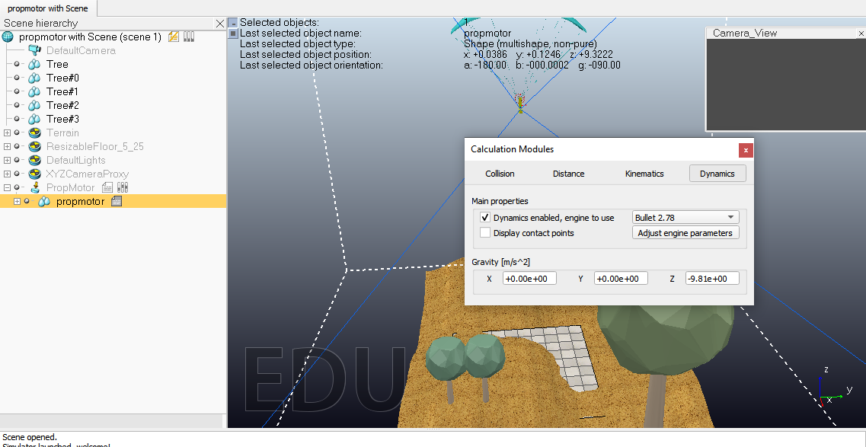

Here are the mathematical principles of moment inertia and Matrix of independent Inertia.

Solid Sphere Inertia Time:

In Physics the time period of inertia has a unique meaning. It is associated with the distribution of the weight of an object (or many objects) in relation to an axis. This is different from the definition usually given in engineering direction such as state-of-the-art properties, phase frequency, approximately axis.

A solid cylinder rotating on the axis that passes through the center of the cylinder, with the masses M and radius R, has a moment of inertia determined by the formula:

I = (1/2)MR^2

The major moments of inertia are given by the diagonal second entries of the inertia matrix and are denoted by (solid) A, B and C to reduce the intensity. In the most important axis frames, the moments I_ (xx), I_ (yy) and I_ (zz) are also indicated each time. The required axes of the rotating frame are explained by finding the values ​​of i.

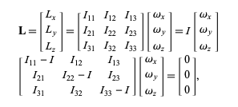

**Control Mechanisms**

Control Mechanisms include

* Embedded Script => LUA
* Remote Apis Client => MATLAB, Octave, LUA Python, C/C++, JAVA
* ROS NODES => C/C++, Pyhton
* Add Ons => LUA
* Plugins => C/C++

In our project, we use embedded scripts and add-ons. LUA is attached to any visible object. Many Lua extension libraries are available. Thread or non-thread master script, child script, backscript are available. Lua interface

Lightweight and easy program (lua scripts)

Enabling Activation Sensing → Shutdown

The add-on simulator is lightweight, lightweight and easy to set up, starts automatically and runs in the background or they are called Tasks

The description of the control mechanics of the script is given below.

Manages the item only on the basis of its call. The operation of this function depends on the advanced name suffix settings (see accessing sim.GetNameSuffix, sim.SetNameSuffix and common-type objects).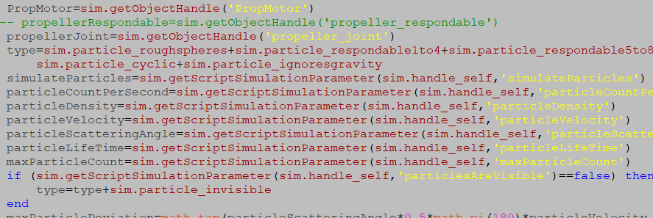

Also find an agreement with the vision sensor you want to stream:

viewSensorHandle = simGetObjectHandle ('Vision_sensor')

Now allow content story publishing and sensory information distribution:

titleName = simExtROS_enablePublisher ('SensorData view', 1,

simros_strmcmd_get_vision_sensor_image, viewSensorHandle, 0, '')

It returns the power or torque created at the junction / about its desired axis. This feature obtains the most logical records when the merits are contradictory or rebellious, and strongly authorized. With a Bullet engine, this function returns power or torque designed for a shared motor (flashlights from shared ends are checked). With the ODE and Vortex engine, this feature returns all the power or torque used in relation to / in relation to its z-axis.

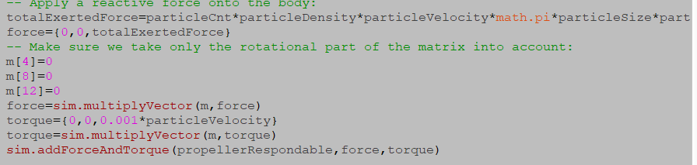

**Algorithm:**

input: Environment

output: Simulation of flying Paramotor Gladiator

1) procedure Flying Model

2) scan environment using sensors

3) detect objects using vision sensors and show on floating_view

4) calculate model object and dynamic properties

5) perform Euler angle Algorithm/Formula to calculate moment of inertia and Matrix of inertia

6) end procedure

**Run The Project:**To run this project open the vrep tool. After opening tool, go to file and click on open scene. After clicking this, you may select the scene of paramotor from your device. When you open this, you see the whole environment with model.

For running simulation, you should click on play button and your simulation runs. You can also check the scripts and model properties by using the tool button and click scene object properties.

**4.10 Solidworks**

SolidWorks is a static modeling laptop-aided design (CAD) and laptop-aided engineering (CAE) computer software that typically runs on Microsoft Windows. It allows designers to actually build their passivity, they can make caricatures in 3D. In SOLIDWORKS design, we visualized the models from three angles, the model existed after My was built. These conditions apply to the SOLIDWORKS software program and documentation period.

The source appears as two blue arrows and indicates the coordinate (0,0,0) of the model. When the comic strip is activated, the sketch source appears in the color play and indicates the (0,0,0) coordinate of the caricature. You can upload dimensions and family members in the original model, but no longer in the original sketch.

Aircraft flat production geometry. You can use airplanes to add a 2D cartoon, section view or neutral flight version to the format.

Axis Variant A straight line is used to create geometry, features or patterns. You can create an axis in a specific way that can connect the two planes. The SOLIDWORKS app creates a temp ax in a pattern for each conical or cylindrical face.

Facial boundaries that help define the shape of a model or surface. The face is a variant or selectable area of ​​the surface (planter or nonplanner). For example, a rectangular cube has six faces.Edge space or extra faces are ideal with each other. You can select edges for sketching and dimensioning.A ridge where two or more trunks or edges meet. You can select a corner for sketching and measuring.The design / version of the paramotor and all its components can be used for complete mechanical construction.

**4.11 Ansys**

Ansis, Inc. Worldwide open organization situated in Kansas, Pennsylvania. It creates and showcases multifix building recreation programming programs for item structure. Ansis was established in 1970 by John Swanson. In 1993, Swanson offered his enthusiasm for the organization to work with speculators. In 1996, it was distributed in the ANSI NASDAQ. During the 2000s, Ansis made a few acquisitions from other building format organizations, acquiring extra ages for liquid elements, gadgets structure and other physical examination.

It very well may be utilized to break down parts made with solids. The principle investigation depends on the CFD and draws in and duplicates the coefficients.

**Chapter 5-**

**Results**

**5.1 Mathematical model for the mechanism:**

Mathematical modeling is the art of interpreting difficulties and formulating possible solutions from an application area into controllable mathematical formulations whose theoretical and numerical study provides deep analysis and predictions about the desired outcomes. A mathematical model of the paraglider's motion in the longitudinal plane is constructed. This vehicle has a sail and the mount. Both bodies are considered to be fully rigid. They are attached to slings which are considered to be fully rigid rods. Therefore, the model behind the paraglider represents a solid body with three degrees of freedom. The engine, which develops thrust using a propeller, is mounted precisely on the vehicle's gondola. The orientation of the thrust vector is constant with respect to the mount. The steady-state setting of the paraglider speed was found for constant thrust. The rule of automatic thrust control, for which the flight of the vehicle is fixed at a given height. Our Mathematical model is mainly focused on the drag and lift force acting on the parachute and the motor while the machine is flying in the air; also the balancing of the motor and its components were definitely taken into accounnt. To break it down the part that is in due consideration is the Parachute, that is responsible for changing of the position/path of the motor. The basic concept of this parachute mechanism is the principle of aerodynamics. When the thrust is applied by the motor below the para the difference of pressure is generated above and below the parachute; thus this air manipulation would generate the lift. So we are taking into consideration Our Mathematical Model consist the relation between weight, air and pressure. We did a complete analysis on it because parachute is the only vital part in controlling the flight.

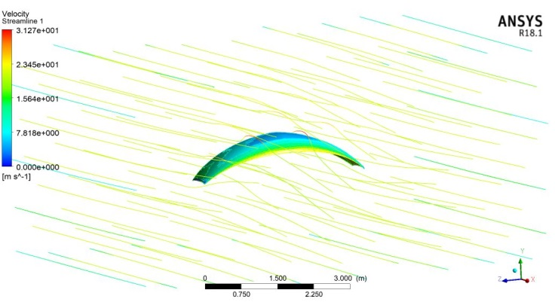

Figure 11

Velocity and pressure analysis.

Also we take into consideration the effects of changing length and area of the parachute to subsequently find the unknown parameters accordingly. But overall the important things to cater in the scenario are drag and lift force.

|  |  |
| --- | --- |
|  |  |

Figure 12 Effect of lift force Figure 13 Effect of Drag force

**5.2 Design and Calculations**

The first portion of the mechanical model is the most important as it is the core working component of this project .Firstly the mount for the motor is designed, then using the mathematical model and finite element method its compatibility, utility and endurance would be verified, if it is up to the set standard with a slight margin of error, then this project will move to the second part of the project which is the complete assembly of the motor and parachute.

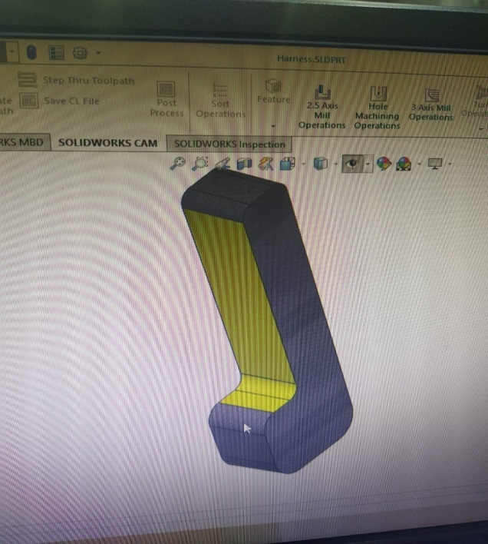

Figure 14 The Mount

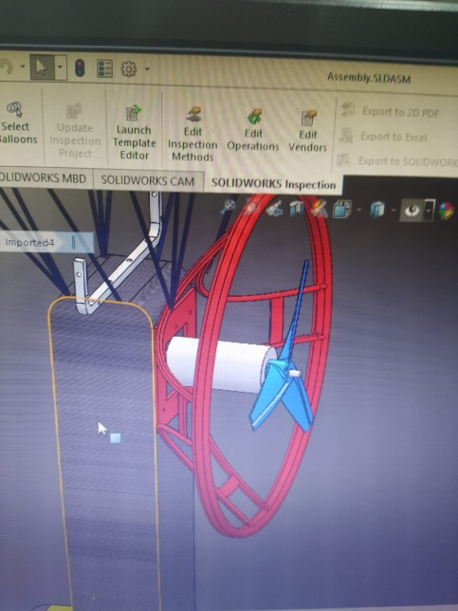

Figure 15 Motor Cage

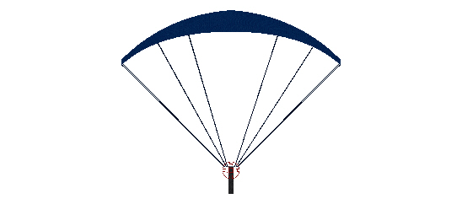

Figure 16 Complete Assembly

There will be two servos in use to control the flight via parachute strings. A servo motor is a tool with an encoder that converts rotational movements (metal turns) into visual holes translated by a motion controller. There is also a driver; and together, they form a cycle that controls position, torque and speed.Their main features are torque and speed.

The servo vehicle contains:

• Electric motor: That is the price of producing movement with its shaft.

• Management system: This system allows you to control the flow of traffic by sending electric sprays.

Power system: Built using gears that can increase or decrease velocity and torque.

• Potentiometer: It is attached to a key hole, and always informs the angle at which the car shaft is positioned.

# **5.3 CFD Modeling**

Ansys was used to perform CFD analysis of the parachute. The lift and drag forces plots are obtained. The velocity and pressure streamlines were obtained. The k-epsilon model with scalable wall functions are used for performing computational fluid dynamic analysis.

# **Mesh**

The mesh convergence study was performed, and mesh plot is shown in the figure given below. Tetrahedral elements were used with adaptive meshing technique.

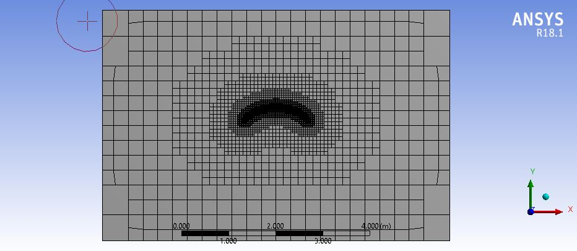

**Results**

Ansys Fluent was used to obtain results. The results obtained are presented below:

**Lift and Drag Forces**

The lift and drag plots are obtained and are presented below. A lift coefficient of 0.7 was obtained. The results are converged and are independent of the mesh size. The resultant drag coefficient of 0.15 was obtained. Higher lift coefficient results in longer flight whereas the drag coefficient signifies the motion resisting force on the glider. A high coefficient of 0.7 depicts the better flight characteristics of the glider.

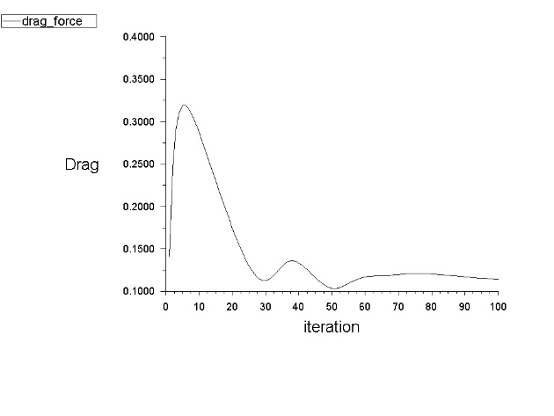

## **Pressure Distribution**

The pressure distribution plot is shown in the figure below:

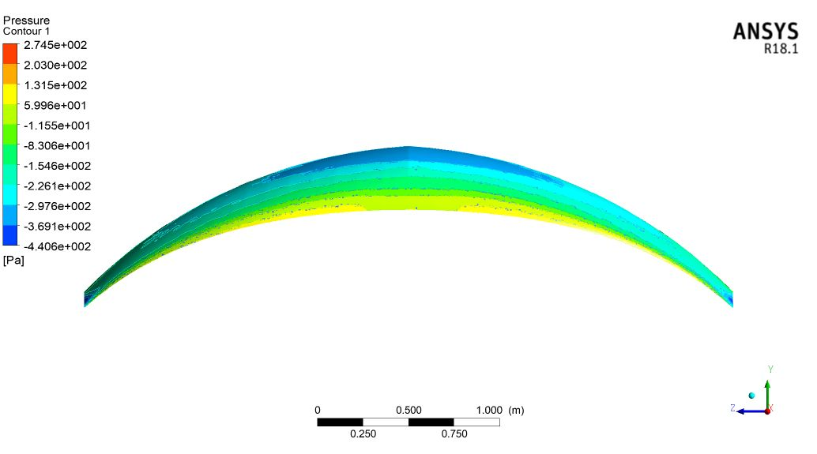

Lift is generated when pressure under glider is more than the pressure above it. The average pressure of 274 kPa was obtained under the glider whereas a negative gauge pressure of -4 kPa was obtained on the upper side of the glider.

**Velocity Distribution**

The velocity streamlines obtained are shown in the figures given below. It is clear from the figures that a vortex is generated at the sides of the paraglider. High pressure zones have low velocity. The velocity of the air above the paraglider obtained was higher than the velocity of the air under the glider.

Our model suggests that, even for just two cells, individual velocities exhibit a distortion, which depends on the increase in the correlation between interparticle separation and cell velocity. When examining multicellular systems, we found an analytical expression that relates the total velocity difference across the density, mean-field level, and small distribution correlations to a valid pair-side distribution function. Finally, we discuss the main differences between the theoretical scenarios proposed so far for ingenious similarities and their effective free energy functional and phase-separating active cells.

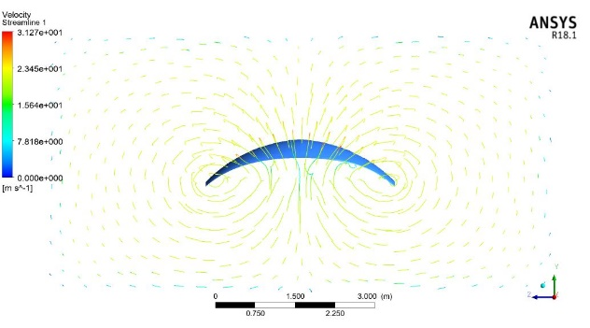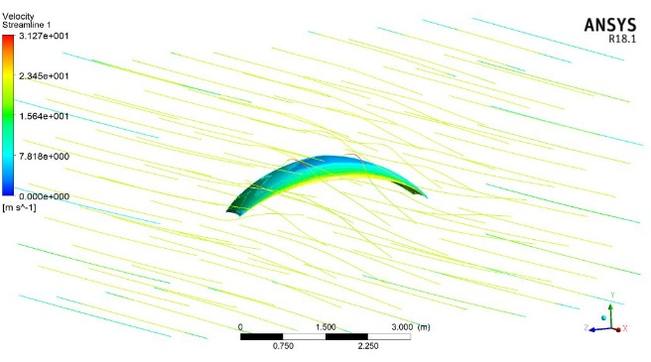

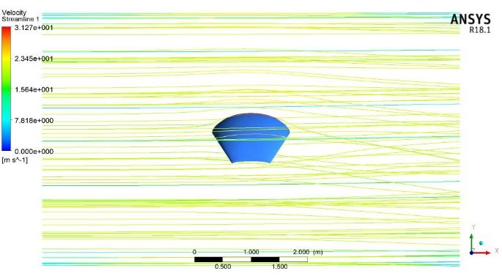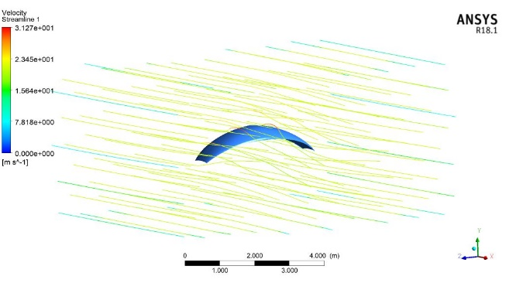

**Flight Dynamics**

The movement of a rigid body can be described by the sum of all forces **F** and torques **M** acting on the vehicle:

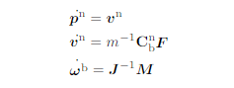

Here, p ^ n and v ^ n the placement and speed between the graffiti body in the (inertial) navigation system, ω ^ b its deviation level is given to the network frames and the Cnb is the rotation number that turns the veterinarian from frame (indicator b) to in the transmission link (index n). The mass m and inertia J of the quadrotor need to be recognized and the element is expected to measure individual components and to use a geometric model. Force vevel F has motor thrust FM, power diarrhea Fd and gravel vector Fg. The torque vector M is divided into MM torque and delays Md. Drag troops and times provided:

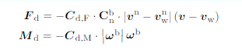

Finally the gravity force is given by:



With these forces and torques resulting from self motion of any system in space and the propulsion forces and torques.

**Center of Gravity:**

The point where the center of gravity G is the whole all stripes are equal to zero due to the forces of gravity. Both Torque is due to the weight of the pilot and the weight of the paraglider. Consequently, the distance can be determined. With this information, center of gravity is calculated with the help of length of the suspension lines.

**Summary/conclusions**

The group was effective in making ParaGladiator in equipment just as in reenactment, a framework that is fit for flying in air and give ongoing criticism utilizing camera/vision sensor with 100 percent achievement rate. ParaGallidor likewise can mosaic guide of condition progressively in future utilizing GPS while being constrained by a client or move self-governingly. Blunders in the general way were broke down and the group accepts the mistake can be diminished significantly pushing ahead. Issues emerged while actualizing all the imagined usefulness, in any case, each unmistakable framework works freely and the group is confident that full execution would have been conceivable with more time.

Innovative work for utilizing apply autonomy in space/condition which can artistic creations progressively have developed essentially in the previous hardly any decade; in any case, to this date, a business robot Flying and planning is as yet inaccessible for top zones where individuals can't go effectively and make a guide of that place with out the aiding of satellites. Production of an advanced environmental factors was done as a reaction to the creation of guide. This could bring about progressively reasonable reproductions, in light of the fact that the model elements could have a superior impact at the outcomes.

By finishing the undertaking the group figured out how to utilize devices and material science of model. The colleagues didn't have V-REP and SOLIDWORKS experience before the fruition of the undertaking. V-REP and SOLIDWORKS while amazing and an incredible apparatus makes them learn bends that the group didn't foresee. The group likewise took in the significance of cautiously characterizing work regions for the Powered Paragalidor. Because of it being a reproduction the paramotor would once in a while perform moves that are not genuinely conceivable, thusly, to keep with the possibility of this being conceivable in reality the group needed to think about further physical requirements for this model.

A contention can be made that the group was excessively driven toward the start of the venture, in any case, the group unequivocally accepts that whenever given more time the two primary segments of the finished undertaking can be connected making the general introductory vision. At present straight speed for each motor can be gotten to that would play out the necessary development inside V-REP, in any case, the group accepts a counterbalance is being applied the V-REP worldwide directions. Pushing ahead the group would concentrate on fixing the current issue and accepts that if this issue is settled the vehicle ought to proceed as at first structured.

**FUTURE WORK**

The aim is to get this project go on a commercial use. For that purpose there is still some major work required on the field. Unfortunately due to Covid-19 pandemic we were not able to pursue this project on the field but still its basic structural model is complete and ready to test on field. Since we have completed its software simulation yet there is always the margin of improvement to get better and useful results, hence from the software point of view we can attach a payload beneath the main structure to carpet bomb the seeds on the fertile soil and gain the purpose of foresting and help the nature specially in this era of climate change problems. We can also use this product for the aerial mapping and mosaic outputs. Mosaic map is basically a map made up of different images. It can have different overlapping layers, so you can find different layers when you zoom in or zoom out. The best example of it is Google maps. That software is based on mosaic mapping.

However, on the field major work is required to get this product work in a hardware form. All the synchronization between the hardware and software is required. It is definitely known that there will be comprehensive change in the environment on the field as compare to the software simulation because when we gain hands on experience, there is always a significant change of constraints which one cannot cater for unless known to the similar situation. Hence days of practice and abstracting information from them are required. Although we have worked out almost every accessory required like main power motor, battery, servo motors, their power ratings and requirements to perform wanted tasks.

As you know everything testing on hardware is costly and risk factor weather it works fine in first attempt or not. So that, we think to integrate our hardware model to software in which user can operate this model via keyboard and view it on monitor screen. For Integration we use Remote APIs functions and sensors which connects our hardware model to Joystick/Keyboard. Mosaic mapping done by our model can be easily view via monitor screen and we can save it to cloud database. The advantage of this, we can save labor cost and time. Hill sided areas, where people cannot go easily and have don’t access of google maps we can send our model in air and control it via keyboard and view it on screen and where our model go it create mosaic map and we save it in cloud db.

A next step would be to use V-REP as a Robot Operating System (ROS)1. By using a ROS it is possible to connect e.g. real sensor software that then can be used to create a Software In The Loop simulation. This would give a more accurate result how the methods would work in real life, due to the induced behaviors of the real firmware.

**REFERENCES:**

1. *Goin, Jeff (2006). Dennis Pagen (ed.). The Powered Paragliding Bible. p. 253.*[*ISBN*](https://en.wikipedia.org/wiki/International_Standard_Book_Number)[*0-9770966-0-2*](https://en.wikipedia.org/wiki/Special:BookSources/0-9770966-0-2)*.*
2. [**^**](https://en.wikipedia.org/wiki/Paramotor#cite_ref-2) [*"Marks Paragliding Pages"*](http://www.marksparaglidingpages.com/)*. First Electric PPG. Mark Andrews. 2006-06-13. Retrieved 2007-01-25.*
3. [**^**](https://en.wikipedia.org/wiki/Paramotor#cite_ref-3) [*"Electric PPG Questions"*](http://www.electricppg.com/)*. Electric Paramotor Website. Airhead Creations. 2006-06-25. Retrieved 2007-01-25.*
4. <https://www.researchgate.net/publication/262247993_Comprehensive_Simulation_of_Quadrotor_UAVs_Using_ROS_and_Gazebo>
5. <https://www.jameco.com/jameco/workshop/howitworks/how-servo-motors-work.html#:~:text=Servo%20Motor%20Applications,good%20power%20for%20their%20size>.
6. <http://www.diva-portal.se/smash/get/diva2:1359785/FULLTEXT01.pdf>

by Nikolai Yotov and Ivelin Kalushkov, SKYNOMAD.

**Conference Paper** · October 2016 *with* 5 Reads

DOI: [10.1109/AUS.2016.7748140](https://www.researchgate.net/deref/http%3A%2F%2Fdx.doi.org%2F10.1109%2FAUS.2016.7748140)

Conference: 2016 IEEE/CSAA International Conference on Aircraft Utility Systems (AUS)

**Conference Paper** · January 2013 *with* 9 Reads

Conference: IEEE International Conference on Robotics and Automation (ICRA)

**Article** *in* [IEEE/ASME Transactions on Mechatronics](https://www.researchgate.net/journal/1083-4435_IEEE_ASME_Transactions_on_Mechatronics) PP(99):1-1 · July 2017 *with* 30 Reads

DOI: [10.1109/TMECH.2017.2728678](https://www.researchgate.net/deref/http%3A%2F%2Fdx.doi.org%2F10.1109%2FTMECH.2017.2728678)

**Conference Paper** · December 2010 *with* 36 Reads

DOI: [10.1109/CDC.2010.5717849](https://www.researchgate.net/deref/http%3A%2F%2Fdx.doi.org%2F10.1109%2FCDC.2010.5717849) · Source: [DBLP](https://www.researchgate.net/deref/http%3A%2F%2Fdblp.uni-trier.de%2Frec%2Fbibtex%2Fconf%2Fcdc%2FTogliaVL10)

Conference: Proceedings of the 49th IEEE Conference on Decision and Control, CDC 2010, December 15-17, 2010, Atlanta, Georgia, USA

<https://www.researchgate.net/profile/Petr_Zaytsev>

Google images.